Tree Establishment Instructions

Even the most resilient and drought tolerant tree species require routine watering and care for several months after planting. In our hot Florida climate with its poor and sandy soils, consistent supplemental water during the initial 2-3 months after planting determines long term health and survival of a planted tree. Follow these instructions to care for your young trees:
- Maintain a “water basin” or “tree ring” around each tree. This allows water absorption directly to the root zone. As you mow or engage in other activities, try not to damage the “tree ring”.
- Apply 2”- 3” of leaf litter or mulch beneath the tree canopy. Mulch benefits a young tree by adding soil nutrients and soil moisture, but most importantly, mulch suppresses weed and grass competition. Reapply mulch, such as leaf litter, or wood chips to augment the initial application.
- Most trees rarely need fertilization. If applied, always follow manufacturer’s directions and only fertilizer during the spring growing season.
- Young trees build strength and flexibility from gently swaying in the breeze. If a staking systems is necessary for stability, the staking system should never rub or affect bark/trunk development. Always remove stalking systems as soon as possible.
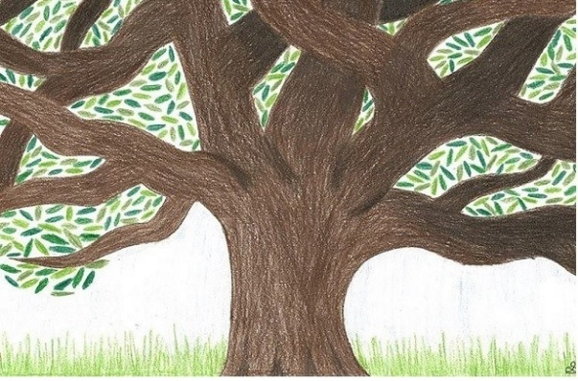
- Structural pruning should take place during the dormant season of the 2nd or 3rd year after planting. Visit the following web site for more information about pruning: https://hort.ifas.ufl.edu/woody/pruning-cuts.shtml
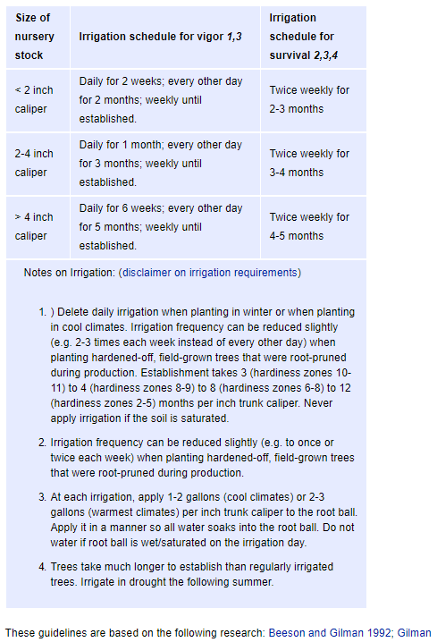

10 steps to plant a tree:
1st Select a tree species suitable for the site conditions! Make sure the tree species you choose has room to grow to its full size. Look around and look up to be sure the space is adequate! Do not plant large trees near power lines or over water or sewer lines. Try to stay at least 8’ from any structures.
2nd Start with a quality specimen! The trunk should be strait and sturdy enough to support the crown. The trunk should be clear of scrapes or lesions. The canopy should be full, uniform with good color and vigor.
3rd Check the roots! Roots are very important! This is the only chance you get to correct root problems. Roots should show signs of new growth when removed from container. Healthy roots have light colored root tips, and flare perpendicular from the top of the root ball. Roots should not be kinked or matted. At the time of planting loosen the root ball and remove or straighten matted or circling roots.
4th Dig a planting hole about 2X the width and slightly shallower than the root ball size. Do not dig too deep! Make sure the root flare and the first lateral root is above the natural level of the ground.
5th Place your tree in the hole and back fill with native soil. Tamp the soil in and around the roots. Make sure there are no air pockets around the root ball.
6th Water deeply and make sure the soil settles around the root ball.
7th Build a “water basin” or “tree ring” around the base of the tree. The water basin is a shallow berm about 3” high and about the diameter of the crown.
8th Apply a thick 1”-3”layer of mulched leaf litter or wood chips around the base of the tree.
9th Remove all nursery tags and tape
10th Stake only if necessary. Use an adjustable or flexible material tied between separate support stakes to hold the tree up right. Stakes must be set far enough away from the tree to prevent rubbing or affecting the bark or trunk in any way.

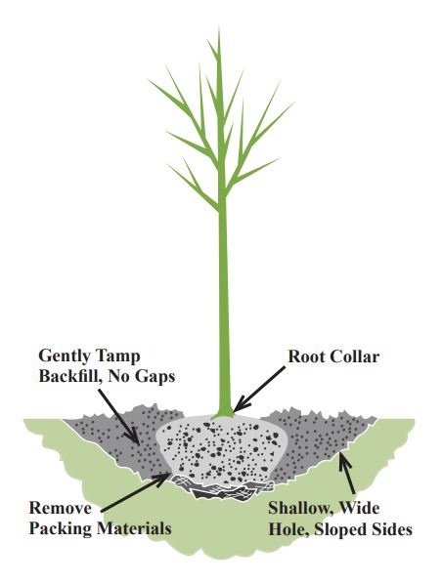
For more information about trees visit: https://www.isa-arbor.com/

