Alachua County
Central Receiving System

State and Local Fiscal Recovery Funds
2022 Report
Table of Contents

Executive Summary 2
Uses of Funds 6
Promoting Equitable Outcomes 7
Community Engagement 10
Labor Practices 11
Use of Evidence 11
Table of Expenses by Expenditure Category 13
Project Inventory 13
Performance Report 14
Required Performance Indicators and Programmatic Data 15
Ineligible Activities: Tax Offset Provision 16

Executive Summary
Alachua County has requested a total of $1.75 million in American Rescue Plan funds via the Coronavirus State and Local Fiscal Recovery Funds in order to develop and implement a Central Receiving System (CRS) in response to the COVID pandemic and other emerging needs, to provide Behavioral Health services in Alachua and the surrounding region of five additional counties. Prior to the onset of the pandemic, the need for mental health and substance abuse services was increasing and, in many cases, exceeding system capacity. During the past two years of the pandemic, the need for services has further increased generally due to the stressors of Covid including health concerns, unemployment and loss of income, loss of life of family members, and social distancing. Issues related to COVID are most exacerbated for people of color, low-income communities, immigrant communities, and those who are most vulnerable and face inequity in our community.
A Central Receiving System (CRS) provides a single point of entry into the Behavioral Health system for assessment and appropriate placement of adults and children in need of crisis services. This includes individuals in need of brief intervention services for those experiencing an acute mental or emotional crisis. In the State of Florida, the Baker Act provides for involuntary commitment of an individual experiencing a mental health crisis (F.S. 394) who may be in danger to themselves or others due to their illness. The Marchman Act provides for the involuntary commitment of someone who experiences a substance abuse crisis (F.S. 397) and similarly may be dangerous to self or others.
As designed, the CRS serves as a single point of entry for law enforcement and others including individuals in crisis arriving alone or brought to the facility by family members or another care giver. The Mobile Response and Co-Responder Teams may also bring people to the CRS. Access to services will be available 24 hours a day every day for those who need help. Currently many affected must use multiple systems, seeking the service or facility that they may qualify for, often entering the wrong door; a CRS increases access in a more expedited and comprehensive manner by accepting any individual brought to or seeking services.
The CRS will offer immediate, short-term assessment, evaluation, stabilization and brief intervention services to those experiencing an acute mental or emotional crisis to prevent further destabilization to get the help they and their families need to address the crisis. The goal of this CRS will be to complete the assessment in no more than 23 hours, and to identify and effect transfer to the most appropriate level of care needed within that time.
The model Alachua County will use represents essentially a pre-arrest diversion method from criminal justice, and also a diversion from other inappropriate forms of care, e.g. emergency room. The CRS enables law enforcement to have a safe alternative to arrest for those in crisis. Finally, the CRS provides an alternative to emergency hospitalization, and thereby reduces inappropriate and costly use of hospital emergency room departments. More specifically we expect the CRS will reduce drop-off processing time by law enforcement officers for admission to crisis services; increase participant access to community-based behavioral health services after referral; and reduce the number of individuals admitted to a state mental health treatment facility; and reduce jail admissions for those in crisis.
Accordingly, we recommend that the Alachua County Board of County Commissioners appropriate $1,750,000.00 of American Rescue Plan funds to support the operation of the CRS.

Project Overview

Alachua County is requesting SLFRF funds to develop and implement a Central Receiving System (CRS) to provide needed Behavioral Health services to citizens in our County. The CRS provides a single point of entry into the local Behavioral Health system for assessment and appropriate placement of adults who are experiencing a Mental Health crisis or a Substance Use crisis. The CRS will serve as a single point of entry/drop off for law enforcement officers, as well as for individuals walking in, caregivers or family members assisting someone in crisis. The CRS will offer immediate, short-term assessment, evaluation, stabilization and brief intervention services to those experiencing an acute mental or emotional crisis to prevent further deterioration of mental health. The goal of the CRS is to complete the assessment within a 23-hour period, and to identify the most appropriate level of care needed. The intended outcomes of the CRS will be to enhance greater Coordination of Care for those in need and encourage improved use of resources –in part by providing an alternative to hospitalization and inappropriate care in the criminal justice system.

The proposed timeline for the CRS project initiates with a formal commitment from Alachua County and its partner organizations, including Meridian Behavioral Health Care as service delivery agent during Summer 2022 to begin the project. Additional partner organizations for funding of planned operations have been sought, including local hospital systems – UF Health and North Florida Regional Health Care. The City of Gainesville is also a partner on capital budget requirements. Efforts to fund construction/renovation of a facility owned by Meridian are underway. Following the securing of financing from local sources during late Fall, construction at Meridian’s existing facility would commence. It is projected that Fall 2023 would see the start-up/operation of the CRS Program. Full operation of the CRS would begin in January 2024. It should be noted that the partner organizations which are health-related will participate as part of an overall coordinated system, the entry point of which will be the CRS itself. Such partners will assist through their commitment to the entire system of beds and related resources necessary to make the system function properly and assure behavioral health crisis care has no gaps for the population served.

For a review of the anticipated model to be used for the Central Receiving System Program by Alachua County, see the following diagram.
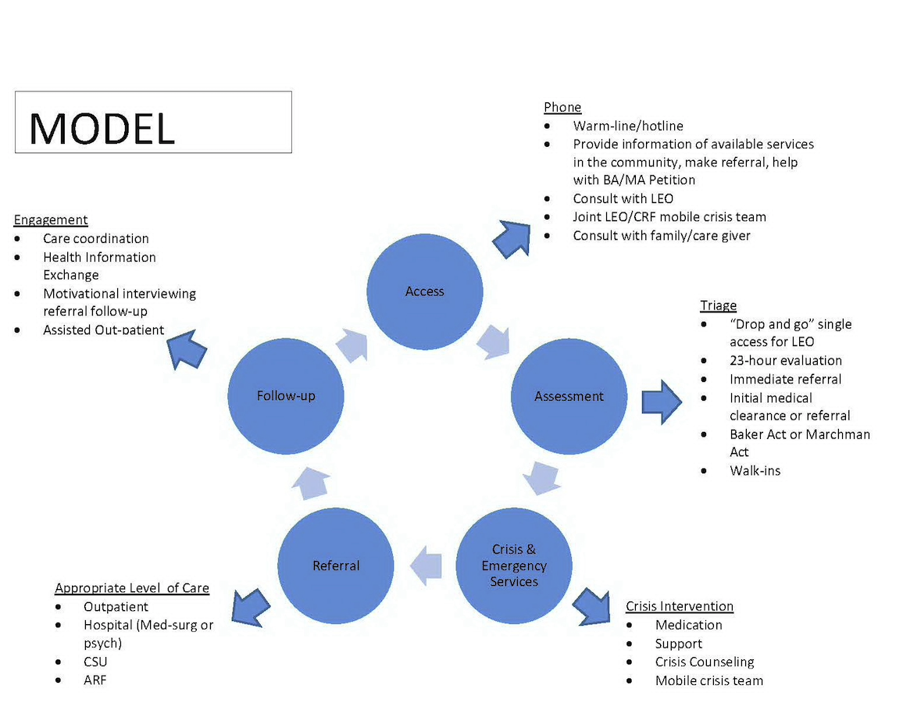

The eligible use of SLFRF funds for this planned purpose is primarily tied to these activities: 1) Supports for vulnerable populations to access medical or public health services; 2) Enhancement to public health capacity; and, 3) Enhancement of public health data systems; and other public health responses.
Because the COVID pandemic has significantly affected mental health and substance use disorders, the priority for this project is responding locally by supporting and enhancing behavioral health services for anyone in need, which also assist in responding to public safety needs. The CRS also adds to and enhances our capacity, and an integral component is establishing a system of community-wide crisis bed management as well as improved coordination of the system of care.
For those lacking health insurance or other financial resources, including those recently impacted by Covid through lost employment, the CRS assures access to needed crisis services regardless of ability to pay. By serving anyone in crisis regardless of any demographic or socio-economic status, the CRS assures access to needed services. This model will by its nature reduce these inequities. Once established, the CRS Oversight Board will monitor service data to assure that the population served addresses these known inequities.
There has been significant development and implementation of multiple CRS’s established throughout Florida possessing excellent models. Some CRS’s have provided a useful laboratory for the Alachua County initiative to learn from, and develop program planning. There are now 10 CRS’ operating in 23 of Florida’s counties. During FY 2019-20, these Facilities served 43,298 unduplicated individuals and effectively diverted over 8,000 people from hospitals for a cost avoidance of $51 million in emergency room expenditures. For a review of the existing Central Receiving Systems now operative in the State of Florida, please see the map of Florida embedded directly below:
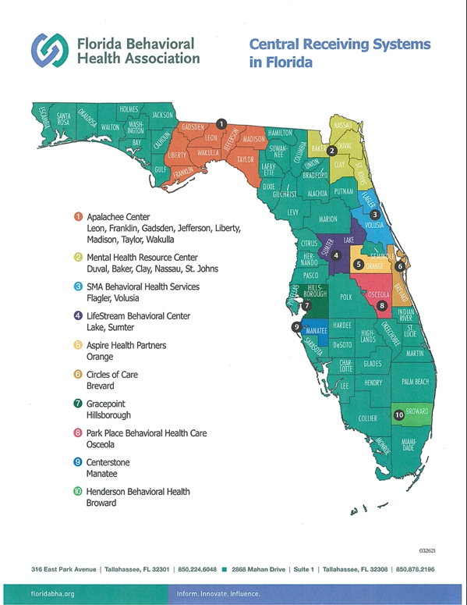

Advocacy has been considerable among a variety of organizations for the development of a CRS for this region for nearly the past decade. More recently the Alachua County Public Safety Coordinating Council (PSCC) Subcommittee on Oversight has provided significant leadership to advance the concept of a CRS. The PSCC includes stakeholders in the local Criminal Justice and Behavioral Health systems, including three major hospital systems. Current plans are to continue to use this forum to examine the progress made toward achieving full operation of the planned CRS. In its deliberations, the Oversight Board has sought to engage the community in discussions about the CRS and assure the voices of the under-served are included.
The proposed timeline for the development and implementation of the CRS is:
- August 2021: Alachua County BoCC commits to develop and implement a CRS
- May 2022: Alachua County BoCC approves staff recommendation to award capital and operational funds to Meridian Behavioral Healthcare to implement a CRS
- July 2022: City of Gainesville, Gainesville Police Department awarded a Legislative Budget Request of $496,500 to support the CRS implementation
- Summer 2022: Commitment to fund construction from the City of Gainesville, Alachua County and State of Florida. Architectural plans, bid process and construction initiation
- Fall 2022 – Summer 2023: Construction of the CRS
- January 2024 Ribbon Cutting and full operation of the CRS
The fundamental framework for the CRS is planned to be represented through the means of a broad public/private partnership developed in our County. Meridian Behavioral Health Care (MBHC) serves as one of the public providers among the four designated receiving centers engaged in operation of the local coordinated receiving system for the County. MBHC is the designated public receiving facility for the County and region, as far as mental health and substance use related services are concerned. Additionally, there are multiple public and private hospital systems providing behavioral health care, including: the University of Florida (UF) Health Psychiatric Hospital; North Florida Regional Medical Center (NFRMC); and the Malcolm Randall Veterans Administration Medical Center. In addition, Alachua County and the City of Gainesville are also strong local public partners committed to the development and implementation of the planned CRS. The CRS is one project among several others, the City of Gainesville and Alachua County are undertaking to address known health disparities and inequities.
The overarching intended outcomes are the development of a facility suitable to house the CRS, and the initial period of operation of the CRS Program. As a result of a CRS put into operation, the following objectives are sought for our community, for those in need of Behavioral Health crisis care:
- A single point entry into the Behavioral Health system, including immediate assessment and placement of adults and children experiencing crises as defined under Florida Statute to improve access to crisis and other services.
- The creation of a single point of entry for law enforcement, family members/significant others, and individuals, saving time and resources to get people the help they need.
- A pre-arrest diversion method so that citizens needing crisis care are not placed in unnecessary settings such as jail but are diverted into appropriate treatment while respecting public safety needs.
- An alternative to hospitalization, including the unnecessary use of hospital-based emergency departments, reducing costly and inappropriate care especially for our more vulnerable citizens.
- An alternative to avoidable Crisis Stabilization Unit admission through linkage to ongoing treatment like outpatient services.
- Provide a 23-hour hold for patient safety and provide timely transfer to partner receiving facilities where indicated.
- Significantly enhanced coordination of care for those in crisis, including timely access to and tracking of efforts for follow up care.
- Improved data sharing across the system, to enable better planning and support greater quality of Care and Coordination to address healthcare disparities within vulnerable populations.
- Strive to achieve service delivery impact demonstrating greater equity and inclusion for those who have been disproportionately impacted by COVID-19 through community engagement and outreach.
Uses of Funds
The Expenditure Category under which this particular Alachua County project falls is Public Health (EC1.10 and EC1.11).
SLFRF funds are sought for the purpose of supporting the operation of the CRS for its first 18 months of operation. A new CRS for Alachua County requires funding of $1,500,000 to construct an attached facility at MBHC to provide the space needed for the screening activities to be carried out by the CRS. Alachua County and the City of Gainesville have committed local funding in addition to a one-time award from the State of Florida to provide for the construction.
The second CRS funding component requires support for the staffing, administrative and related costs necessary to operationalize the CRS, for 24 hour/7 day, 365 per year coverage. The estimated total expense is $2,500,000 in operating costs for the start-up period. The provider will seek Federal and State revenue as well as insurance reimbursements to cover a portion of the operating cost. Lutheran Services of Florida has committed $500,000.00 towards the operating cost for State Fiscal Year 22-23.
The $1.75 million in SLFRF funds will enable this initiative to operate through the start-up period, and for up to possibly as long as 18 months. During this period, the local partnership under County leadership will prepare and secure the necessary financial commitments to continue the operation of the CRS on an ongoing basis with a goal of sustainability. Toward that end, the County’s actions taken on August 12, 2021, included authorization of specific requests for participation in funding the CRS from: the City of Gainesville; UF Health; NFRMC; and the Malcolm Randall Veterans Administration Medical Center. Additional support will be sought from the surrounding counties for their own respective commitments by MBHC.
Toward ongoing operational costs, there is the potential use of State of Florida funds, namely through a funding vehicle called the Low-Income Pool. (The funding is used for hospitals and other health care providers who provide uncompensated care to Medicaid recipients, or other Floridians who are either uninsured or underinsured.) The opportunity to use this funding mechanism has been approached more recently in the State Legislature by three Florida Counties (Brevard, & Polk/Hardee Counties.) Alachua and North Central Florida will pursue this opportunity, to secure sustainable funding, along with local public and private resources. Additional funding opportunities may be sought through grants including Department of Children & Families for Central Receiving.
Promoting Equitable Outcomes
The commitment of Alachua County to promote equity across the County is profound and has been steadfast. More recently, as part of the County’s Strategic Plan formally adopted by the Board of County Commissioners in early 2021, it is noted that the County seeks the goal of being an “Equitable and Resilient Community.” Equitable is defined as “striving to treat everyone justly according to their circumstances, providing opportunity and access for everyone, while focusing on closing existing equity and access gaps.” Further, a fundamental component of the Plan’s second major goal “Achieve Social and Economic Opportunity for All” is the initiative to build equitable access to health (physical and behavioral), safety, and opportunity especially for those who haven’t traditionally had access to those systems. The effort to develop and implement a Central Receiving System is directly in line with the County’s Strategic Plan.
Further, consistent with the aims of its Strategic Plan, the County has recently created an Office of Equity and Community Outreach to focus additional resources to address these issues across the range of County programs and organizational infrastructure. In response to the COVID-19 Pandemic, the Office submitted a SLFRF plan entitled “Building the Language Access Infrastructure of Alachua County Services for Limited English Proficient Speakers (LEP): An Equity Response to Disparities Experienced During COVID”
Racial equity intersects issues of race, economic class, nationality, literacy, and language. To achieve greater equity and inclusion, the County needs to acknowledge and commit to responding to the linguistical and literacy diversity of its residents, especially those identified as limited English proficient speakers (LEP). The COVID-19 pandemic revealed inequities in information and services to non-English speakers, resulting in negative health outcomes and economic disenfranchisement. These issues have been exacerbated by historic disparities impacting immigrants, refugees, Puerto Rican monolingual-Spanish speaking neighbors, and lower-literate community members in the County. Core Components of the plan include and address:

A) Development and implementation of a Language Access Plan to be responsive to the 1964 Civil Rights Act Title VI and Executive Order 13166 requiring entities receiving federal financial assistance to provide meaningful access to programs and services for Persons with Limited English Proficiency (LEP).
B) Training of all County employees on the 1964 Civil Rights Act Title VI, Executive Order 13166, and the Language Access Plan, the existence of the County’s LanguageLine contract and other translation/interpretation service provider options, training to assure that all employees seamlessly utilize the County’s language access options and serve non-English speakers equitably.

C) Translation of Vital County-driven Information about programs in its existing mediums

D) Funding of an Immigrant Neighbor Guide, developed by community organizations serving immigrants to explain systems, protocols, and rights to services, language access as well as their responsibilities as neighbors.

E) County signage in multiple languages to reduce barriers to accessing services, attending events, and locating County offices and structures (i.e., vaccination sites, food distribution locations).

Further County-wide efforts to promote equity and engagement include the findings and recommendations in the Alachua County Community Health Improvement Plan for 2021-2024 adopted in December 2020. Among the six Strategic Priorities identified in this document was “Access to Health Care and Community Wellness, including Mental Health Access. The Plan states that for Access to Health Care a focus on health disparities, including differences in health outcomes and their determinants between segments of the population as defined by social, demographic, environmental and geographic attributes, must receive the County’s attention and focus.
As a practical matter, the County’s efforts to promote equitable outcomes in the use of ARPA funds through the planned CRS project will be affected by the nature, purpose and characterization of the CRS model. The CRS is intended to be a single point of entry into the local Behavioral Health system for use by law enforcement as well as consumers and their family members’ if applicable. The population intended to benefit from CRS services are those citizens affected by significant Behavioral Health or Substance Use crises. Through the CRS, this group will be assisted to secure immediate access to assessment services and appropriate placement. The Provider chosen to operate the CRS utilizes evidence based and culturally appropriate clinical practices.
CRS’s are designed in principle to accept all those who are presented at their doors and are in need of immediate crisis care. It is well-established that behavioral health issues affect all citizens without consideration of income, race, general or ethnicity. Hence, the catalyst for identifying those who will receive services will be determined by the extent of behavioral health issues among the populations presenting the need for the specialized type of services offered by a CRS. Enabling public access to services reduces the stigma of involving law enforcement and promotes the use of CRS services for those traditionally under-served communities.
There is a strong commitment in the County that targeted goals and outcomes should be established which demonstrate that we are using SLFRF funds in a manner that is equitable, fair and considers historic lack of access to services among our different populations. Demographic data is available and will assist in preparation of a thoughtful and responsive platform for CRS program development.

Research nationally in the mental health field repeatedly demonstrates some populations are under-served due to cultural boundaries, lack of transportation, insurance, and financial resources. For example, “studies show that ethnic minority populations are just as much at risk for mental health conditions as their white counterparts, but receive substantially less treatment “(NAMI, 2017). According to the American Psychiatric Association, “while trends have shown that overall rates of mental health treatment have increased, gaps in access to mental health treatment between African-Americans, Latinos, and non-Latino whites continue to persist” (APA, 2017). In 2018, 58.2% of Black and African American young adults aged 18-25 and 50.1% of adults aged 26-49 with serious mental illness did NOT receive treatment. Additionally, nearly 90 percent of Black and African American people over the age of 12 with a substance use disorder did NOT receive treatment. Again, the open and no wrong door approach of the CRS addresses these gaps.

Our planned activities to achieve outcomes related to increasing equity and access are based on the current make up and population trends. According to the U.S. Census population estimates for July 2019, almost 70% of Alachua County is comprised of white people, followed by over 20% Black or African American, and over 6% Asian. Additionally, over 10% of the population reports a Hispanic or Latino origin. The following data table provides a snapshot of the racial make-up of Alachua County.

Race and Hispanic Origin* % of Population
White | 69.9%
Black or African American | 20.6%
American Indian and Alaska Native | 0.4%
Asian | 6.2%
Native Hawaiian and Other Pacific Islander | 0.1%
Two or More Races | 2.8%
* Hispanic or Latino Origin = 10.5%

In developing its plan for implementation, the Central Receiving System will consider the needs of those who speak a language other than English. Strategies to address these findings are outlined in a later section of this plan.

Language Other Than English Spoken at Home, Number of Persons Age 5 and Above
N = 247,336 (2010); N= 269,043 (2019)
Language Spoken | 2006-2010 | 2015-2019 | % Change
Asian/Pacific Islander | 7,379 | 9,374 | 27.0%
Indo-European | 7,997 | 8,812 | 10.2%
Other Language | 1,265 | 1,215 | -4.0%
Spanish | 14,776 | 16,230 | 9.8%

The Alachua County Central Receiving System will be committed to enhancing awareness and understanding of multiculturalism internally and within our community. As a community of helpers, we are dedicated to growth, unlearning and relearning, and moving towards mutuality in relationships.

Goals

- Prepare for and address the population trends, particularly for individuals where another language other than English is spoken at home.
- Address the disparities identified in the Community Health Improvement Plan, Access to Health Care and Community Wellness, including Mental Health Access
- Training and awareness for all involved in the CRS including stakeholders, management and administrative, and all other personnel
- Support the use of multi-cultural practices at all levels of service provided

Awareness

At its very nature, the CRS is designed to accept anyone presenting at the facility. The CRS will undertake efforts to promote the availability of services in under-served areas of the community as an alternative to law enforcement when appropriate, e.g. self and family referrals. This will help alleviate the mis-understanding that mental illness is a crime. The availability of the CRS will be incorporated into aspects of the language initiative as well as promotion of 988 the Mobile Response and Co-responder Teams.

Access and Distribution

An oversight body is charged with monitoring and evaluating the CRS operations and will include a review of demographic and other data to identify trends in usage and case dispositions with respect to equity and inclusion.

Outcomes

- Reduce the disproportionate arrest and jail booking rates for those individuals experiencing a mental health crisis.

- Reduce the disproportionate number of Baker and Marchman Act commitments.

- Increase the warm handoff and successful transition of those experiencing a mental health crisis to other systems of care, e.g., outpatient, peer services, etc.

Measurement

Proper documentation of the characteristics of those who are served by the planned CRS for Alachua County will be provided once the CRS is operational. Quantitative and qualitative data about services, including specific outcomes for disadvantaged communities will be provided during the reporting process for the use of SLFRF funds. Such data will include race, ethnicity and other equity dimensions.
Community Engagement & Outreach
An oversight and community partnership body will be formed to oversee the operations of the CRS. It will be comprised of representatives of those organizations which are engaged as stakeholders in the CRS initiative. As such, partner agencies will include, among others: law enforcement, public sector agencies such as the City of Gainesville and the County; and, behavioral health providers, including the key vendor organization for delivery of services, Meridian as well as individuals who have utilized central receiving services as residents, and community leaders working on behalf of underserved populations will be engaged and invited to participate.
Beyond a leadership/management level, there is keen recognition that engagement and outreach must happen at and within the community to pursue equitable outcomes truly reflective of diversity and inclusion. In order to achieve such aims, the County and its partners in this venture will apply a variety of different tools and approaches.
As previously noted, the CRS will be available to those in behavioral health crisis, and many will be delivered directly by law enforcement. Entry for a significant number of individuals will be via walk-in, including with the assistance of family members. It will be important for members of communities including those for whom language may be a barrier (identified in the table above) to understand fully the role of the CRS, the types of services available and process used to obtain access to services.
Through a collaborative approach with community partners, the County will organize a comprehensive outreach plan to ensure broad involvement among those communities who have been disproportionately impacted historically by poor health outcomes, including behavioral health especially those exacerbated by Covid. County- wide organizations such as the National Alliance for the Mentally Ill/Gainesville Chapter, including consumers of behavioral health services will be critical in this effort. Their assistance will supplement efforts to engage more neighborhood-based organizations representing individuals from households where English is spoken as a second language. Specific opportunities for engagement will be focus groups and workshops in neighborhoods, for the purpose of receiving input about planned services and access strategies for those needing assessment and triage at the CRS.
Community education will also need to include the development of a fact sheet that identifies how to access the CRS within the context of the behavioral health system. This tool must address the stigma of behavioral health needs from a personal perspective and be sensitive to a multi-cultural audience. Further, any such communications tool needs to be fully accessible, which is accomplished by translation in every language used in our community.
A fundamental element of this initiative needs to be listening to members of disadvantaged communities about their own perception of behavioral health issues, gaps in existing traditional helping systems, law enforcement’s role in access to behavioral health services and proposed strategies through the CRS to assist these communities. The first year of the CRS’s development requires rehabilitating a physical structure to accommodate the new program, and planned services. Therefore, there will be a significant advance period in which to engage underserved communities by conducting focus groups and community workshops to obtain perspectives from multiple groups about the planned CRS and its role in serving them, their families and neighbors.
Labor Practices
The planned use of SLFRF funds by Alachua County does not include addressing infrastructure needs. Funding to accomplish infrastructure needs for the CRS has been identified by the County and the City of Gainesville, restricted for capital purposes only.
Use of Evidence
The CRS Program to be implemented with the use of SLFRF funds is firmly rooted in practices identified as priorities by Federal agencies concerned with Behavioral Health and Substance Use and model programs in this field, including best practices and evidence-based practices. According to SAMHSA’s National Guidelines for Behavioral Health Crisis Care: Best Practice Toolkit (2020), the expectations for best practices to operate crisis receiving and stabilization services (such as a CRS) include:
- function as a 24-hour or less crisis receiving and stabilization facility;
- offer a dedicated first responder drop-off area;
- incorporate some form of intensive support beds into a partner program to support flow for individuals who need additional support;
- include beds within the real-time registry system operated by the crisis call center hub to support efficient connection to needed resources; and,
- coordinate connection to ongoing care.
The SAMHSA Best Practice Toolkit also identifies those minimum expectations necessary to operate a crisis receiving and stabilization service. Among other items, it articulates these fundamental expectations for such services: 1) to accept all referrals; 2) not require medical clearance prior to admission but rather assessment and support for medical stability while in the program; 3) to design services to address mental health and substance abuse crisis issues; 4)to be staffed at all times (24/7/365) with a multidisciplinary team capable of meeting all levels of crisis in the community; and 5) to offer walk-in and first responder drop-off options.
As envisioned by the Alachua County public-private partnership, the measures related to best practices outlined by SAMHSA correspond directly to the CRS planning process used to date and undergird our own future development plans in this regard. The focus applied at the Federal level on Behavioral Health crisis care and the need for developing structured, appropriate response systems has also been adopted across many states, including Florida.
In 2016, the Florida Legislature approved Senate Bill 12, which made far-reaching changes in behavioral health care, including crisis care and related transportation services. Senate Bill 12 identified in State law the “No Wrong Door” approach to be the model for the delivery of acute care services to persons who have behavioral health, substance use disorders, or co-occurring disorders. Using the No Wrong Door model and applying it for service expansion to this specialized population, the State’s Department of Children and Families moved forward to support expansion of models of CRS’ throughout Florida, as previously identified in this report. The proposed CRS model by Alachua County seeks to expand upon the platform already established in other areas of the State. In fact, we have used several of these now well-established CRS programs as examples for appropriate system development, firmly based on best practices which draw on evidence-based systems recognized by both Federal and State governments.
During the past four years, Alachua County has received funding from the Bureau of Justice Assistance’s Justice and Mental Health Collaboration Grant Program. The second successive grant received is for three years and includes multiple objectives, which are identified as part of the Embedding a Clinician in Law Enforcement. One such objective includes evaluation and analysis of the local criminal justice and behavioral health systems, specifically targeted at program evaluation using a team of academic researchers affiliated with the University of Florida. The planned CRS Program meets the criteria for an evidence-based intervention. However, the opportunity exists to apply the skills and expertise developed by our research team for the purpose of examining and evaluating program intervention components encompassed during the implementation of the CRS.
In addition to the SAMHSA Best Practices Toolkit, it will be necessary to ensure there are evidence-based practices implemented which relate directly to the achievement of more equitable outcomes for our communities. Discussion of this overarching goal for the use of SLFRF is addressed more fully in Section 9 below, with Performance Indicators to be achieved.
Table of Expenses by Expenditure Category
Category |  | Cumulative expenditures to date ($) | Amount spent since last Recovery Plan
1 | Expenditure Category: Public Health
1.10 | Mental Health Services | $0 | $0
1.11 | Substance Use Services | $0 | $0

Project Inventory
Project [Identification Number]: The Alachua County Central Receiving System Program

Funding amount: $1,750,000.00 for Operations

Project Expenditure Category: EC1: Public Health: Mental Health Services 1.10 & Substance Use Services 1.11

Performance Report
The key performance indicators for the CRS Program which are proposed for Alachua County are based upon designated measures included in the “National Guidelines for Behavioral Health Crisis Care: A Best Practice Toolkit” – and specifically targeted to Crisis Receiving and Stabilization Services. These indicators have been used successfully by communities which are attempting to monitor and improve quality in such programming on a continuous basis. The key performance indicators selected for the CRS when it is operational are:
- the number served by the Program
- the percentage of referrals accepted
- the percentage of referrals from law enforcement (hospital and jail diversion)
- drop-off time for law enforcement
- the average length of stay
- exception report over 23-hour hold
- the percentage discharged to the community
- guest/customer service experience satisfaction
In addition, measurement of outcomes and subsequent evaluation requires planning for how we will be able to identify if equity goals for the CRS are being met appropriately or alternatively if they may require readjustment and redirection. At a minimum, specific metrics will be established and obtained to enable this examination. These will include differentiation of those populations served by the CRS, including by demographics including race, gender, and also geographic neighborhood or community area. Qualitative data obtained from interviews with those who receive services on site at the CRS would supplement the quantitative data developed.
The identification of these metrics will help use monitor the strategies put in place through the CRS and its range of services at the neighborhood level. This process will help the County and its partners evaluate whether our strategies to infuse an equity-based framework for the use of SLFRF funds are making the impact we seek in the implementation of the CRS program.
Benchmarks for collection and assessment of data, including formal measurement periods, will be established and followed in order to achieve proper documentation of performance indicators. The County and its partner agencies, including Meridian, will review and assess the results yielded through that assessment. The following step would be a formal consideration with community partners representing disadvantaged communities of what impact the equity framework being applied in conjunction with the CRS is having. The dissemination of results with partner agencies and members from disadvantaged communities through a public forum would be transparent and enable a valuable dialogue about what has been achieved in equity outcomes and potentially identification of a path forward for doing better.
At the core of development of a Central Receiving System for behavioral health crisis care is the requirement that the institutions engaged in this initiative are integrated parts of a coordinated system of care. This requires constant, substantive communication and collaboration among all of the organizations engaged in the overall enterprise, despite the usual challenges created by developing new services across program and organizational boundaries. There are multiple facets of collaborations and also different ways to evaluate whether the newly developed system truly meets the test of what constitutes a fully collaborative entity. The SAMHSA “National Guidelines for Behavioral Health Crisis Care: A Best Practice Toolkit” suggests the use of a model framework known as “The Milbank Continuum,” in order to help evaluate crisis system community coordination and collaboration. It is the intention of the Alachua County CRS initiative to track and monitor the system being created with the use of such a tool which has achieved significant standing via research in the field of behavioral health crisis care.
There is also the commitment on the part of Alachua County to provide appropriate data about those served by the CRS once it becomes operational. Such data as race, ethnicity, gender, income and other appropriate factors at a minimum will be collected and shared with Treasury. It is likely that as the plan to develop and implement the CRS proceeds during the next year, there will be additional data identified as necessary and appropriate to collect and incorporate into the Recovery Plan Performance Report.
Required Performance Indicators and Programmatic Data
1. Total number served by the program by key demographic data including, age, race, gender, referral source, zip code, prior admission, income level, and insurance type. The demographic data percentage of those served will mirror the overall make-up of the community within +/- 10% of the latest Census data.
2. Drop-off time for law enforcement is less than 15 minutes on average, with 85% of all drop offs less than 15 minutes.
3. Average time of stay is less than 4 hours for 75% of all admissions, and 95% of all admissions are transferred in less than 23 hours.
4. Case disposition report demonstrates 90% parity in the transfer of patients to the other receiving centers.
5. Customer satisfaction data indicates 75% or more of those served are satisfied with the services provided
6. Of those served by the CRS, less than 35% will make a subsequent request for services in 12 months following discharge
Ineligible Activities: Tax Offset Provision
Not applicable

Centers for Disease Control, 2019 Summary Health Statistics: National Health Interview Survey: 2017. Table A-7. Retrieved from https://www.cdc.gov/nchs/nhis/shs/tables.htm

