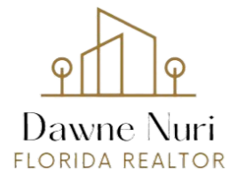
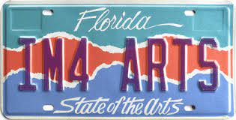
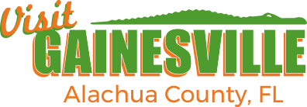
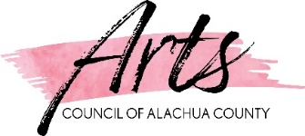

THIRD ANNUAL ARTISTS CONFERENCE
SCHEDULE
“Where Nature and Culture Meet”
Friday, May 3, 2024
9:00 am – 3:30 pm
Cuscowilla Nature & Retreat Center
210 SE 134 Ave, Micanopy, FL 32667

Registration & Continental Breakfast  Sponsored by Alachua County Poet Laureate - E. Stanley Richardson  Registration Open, Networking, and Continental Breakfast | 9:00 am – 9:15 am
Welcome & Introductions  Commission Chair - Mary Alford  Arts Council Chair - Chelsea Carnes | 9:15 am – 9:30 am
Marketing Your Event and Programs  Jessica Hurov – Tourism Director  Participants will review event marketing from start to finish, including how to leverage social media, radio, online, email and other tactics to increase audience size and build engagement. After a brief introduction, attendees will be guided through an interactive session creating the outline of a marketing plan. | 9:30 am – 10:00 am
Generative AI in Art: A New Tool of Expression  Evan Rees – University of Wisconsin – Madison / Research Software Engineer  This session introduces advancements in generative artificial intelligence technology that may be leveraged for artistic expression including examples of where AI may be applied in areas of performing arts, interactive art pieces and creative ideation. | 10:00 am – 10:30 am
Beverage Break  Sponsored by TBD | 10:30 am – 10:45 am
A View from Digital Art  Arianna Leon Uberti  Many question and doubt the value of digital artist’s work for not using traditional methods. This session presents digital art from the perspective of a successful digital artist showing its potential as a viable art medium. | 10:45 am – 11:15 am
Public Art – How to Apply to a Call to Artists  Jenn Garrett - J. Garrett Gallery  This session will cover all the basics of jumping into the world of public art including where to find Calls to Artists, how to format your work, how to organize your information and more. We will talk about the difference between an RFQ (request for qualifications) and a RFP (Request for Proposals). Please bring a proposal you are working on or we will work on an sample proposal together. | 11:15 am – 11:45 am
So You Want to be a Star?  Corey T. Williams – Superior Moves Records LLC  As a published Poet, Corey will share the secrets to his success as an entrepreneur and leader, sharing his television industry experience to enlighten attendees. | 11:45 am – 12:15 pm
Lunch  Sponsored by Visit Gainesville, Alachua County, FL | 12:15 pm – 12:45 pm
AI’s Impact on Your Intellectual Property  Thomas C. McThenia, Jr. – Gray Robinson | 12:45 pm - 1:30 pm
Dance Alive National Ballet is Soaring to New Heights!  Susan Scannella – Dance Alive National Ballet (DANB)  Gainesville and Alachua County's own professional ballet company, bringing 58 seasons of dance to our community, will share plans for their new home, designed for dance and music, with an array of arts offerings and community rental space. | 1:30 pm – 2:00 pm
Beverage Break  Sponsored by TBD | 2:00 pm – 2:15 pm
Piece by piece; Let's sculpt our local metalworking world  Leslie Tharp – Leslie Tharp Designs LLC and Fever Metal Art Center  Alachua County artist, Leslie Tharp, will present on the benefits and potential of increasing access into the world of metalworking for people of all backgrounds.  Through her experience, she understands the impact a strong metalworking community can have developing a local culture. | 2:15 pm - 2:45 pm
These are the Women I Come From  Felicia Walton – DanZe Central! Entertainment!  Enjoy a dramatic presentation comprised of prose, poetry, music and dance. The focus is to aspire, encourage laughter and positive self-reflection. | 2:45 pm – 3:15 pm
Closing Remarks | 3:15 pm

