Alachua County
Recovery Plan

American Rescue Plan

State and Local Fiscal Recovery Funds

Ambulance Transport Support and Premium Pay Program
ARP2021x001

Executive Summary
In response to the COVID-19 Pandemic, the Federal government has provided Alachua County funding through the American Rescue Plan – State and Local Fiscal Recovery Funds. One Category of response is Public Health – Payroll for Public Health and Safety Employees (1.9) and Premium Pay (Public sector 4.1). Alachua County is currently considered a “hotspot” of transmission. As of the week of August 13th, the County has reported 30,824 cumulative cases, and is at a 14.8% positive test rate. (See Weekly Data Table below). The spread of the Delta variant has resulted in increased demand on hospital emergency rooms and admission, including pediatric admissions. (See Hospital Information table on the next page).

Many emergency room visits start with ambulance transport. Alachua County is the provider of ambulance transport services in Alachua County. Alachua County ambulances are staffed with 55 Rescue Lieutenants and Fire Fighters that drive the ambulance. Transports have increased by 21% from October 2020 to July 2021 (See Rescue Unit Responses by Month Table below). The rapid expansion of demand is creating a dramatic workload increase that results in high stress and “burn-out” on the Rescue Lieutenant position. This coupled with a high demand for employees with their medical credentials and work skills have made it extremely difficult to hire and retain Rescue Lieutenants. To recognize and retain these employees and to fill vacant positions, Alachua County will provide Premium Pay for the Rescue Lieutenant position and add an additional 6 Rescue Lieutenant Positions and 6 Fire Fighters that drive ambulances to absorb some of the increased workload.

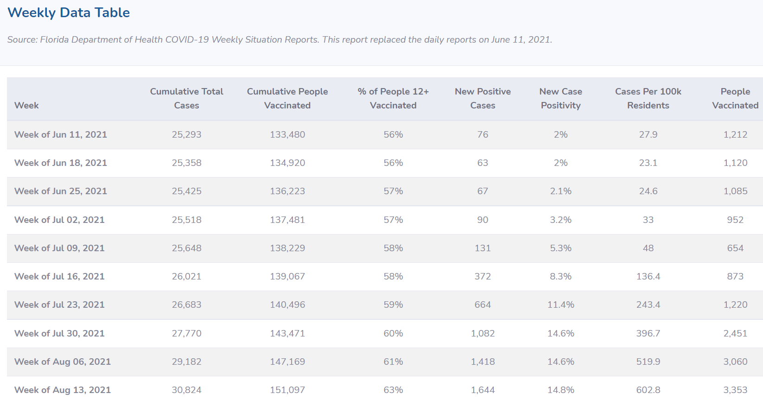

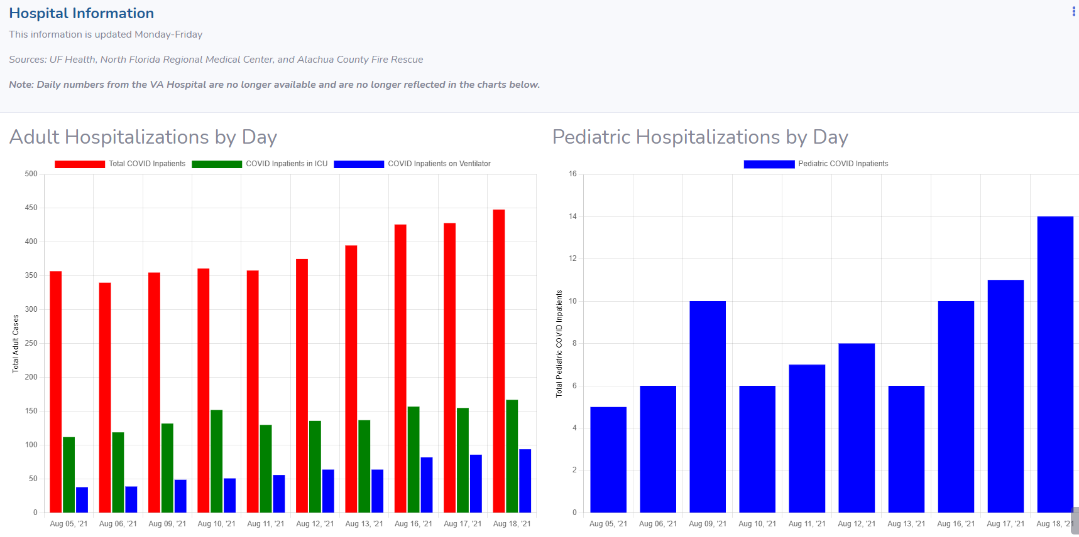

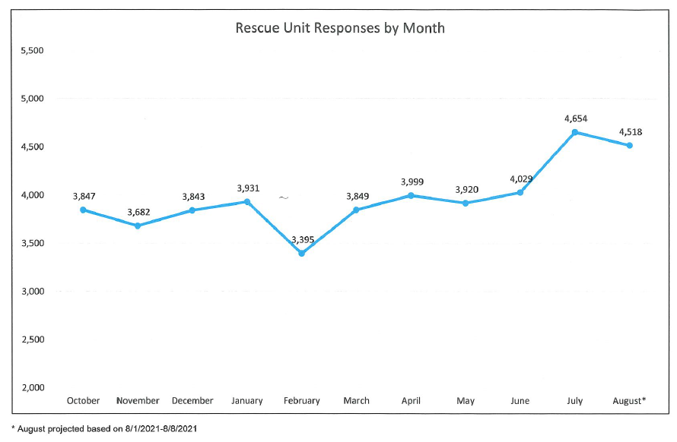

Uses of Funds
The Ambulance Transport Support and Premium Pay Program aligns with the Public Health – Payroll for Public Health and Safety Employees (1.9) and Premium Pay (Public sector 4.1) under the American Rescue Plan – State and Local Fiscal Recovery Funds. Having available ambulance transport when the service is needed can be critical to the health, and possibly mortality, of the citizenry.

Under the Program, 6 additional Rescue Lieutenant and 6 Fire Fighter positions will be created and staffed for 6 months. At the end of 6 months the program will be evaluated and either extended another 6 months or 4 Fire Fighters will phased out through attrition. The phase out of the program will retain all 6 Rescue Lieutenants and 2 Fire Fighters, creating the planned new permanent transport unit from the General Fund. Rescue Lieutenants will be required to provide a 2 year commitment to stay in position, unless promoted to District Chief, and will receive half of the premium pay at 6 months service and the other half at 12 months service. Current Rescue Lieutenants with more than 1 year service will receive the premium pay in October.

The program maximum cost will be $1,070,000, which represents a $10,000 Premium Pay for 61 Rescue Lieutenants, totaling $610,000 and 12 new FTE for 6 months, totaling $460,000.

Performance Report: Goals and Measures
The program will run from October 1, 2021, to March 31, 2022. ACFR will on-board these positions as quickly as possible to relieve current workload levels.
Our goal is to fill all Rescue Lieutenant Positions and retain at least 95% of all Rescue Lieutenants and reduce call load per unit by 15%. We will measure and report progress to the Manager on a monthly basis and provide a final report of effectiveness of the program in April 2022.
June 30, 2022: While the premium pay was helpful in compensating senior employees that continued to provide public safety services to the public during the pandemic; the incentive was not successful in recruiting and retaining new Rescue Lieutenants. The ABoCC currently has a 25% vacancy rate.

