**Eastside Urgent Care Initiative**

**Program Description**

Scope of services

* The initiative will develop and install an urgent care clinical service for east Gainesville and the eastern portion of Alachua County.
* Urgent care is an important part of the continuum of medical care communities need. In terms of the scope of acute medical care delivered, urgent care is positioned between a typical doctor’s office and an emergency room.
* Compared to a typical doctor’s office, urgent care centers offer more x-ray and on-site lab capabilities, perform more procedures (e.g., casting/splinting and suturing lacerations), and have the capability to provide IV fluids. Urgent care centers typically do not provide ongoing continuous care of chronic diseases, but work hand in hand with primary care and specialty providers, public health units and others who provide that portion of the continuum of care. Compared to emergency rooms, urgent care centers are not the intended destination for those experiencing major trauma or life-threatening emergencies.

Access

* UF Health Eastside Urgent Care will provide services to individuals of all ages and with all types of medical problems. Patients of all insurance categories will be seen, as will patients with no insurance coverage.
* The urgent care center will use an open access model, which means that individuals will be able to walk in and receive care without advance appointments required.
* The initial proposed operating hours of the urgent care center are 7AM - 7PM, Monday through Friday, and 8AM – 5PM, Saturday and Sunday. Ultimately, the operating hours of the urgent care center need to match those times when individuals are most seeking services, so as we gain experience with the timing of patient demand, the operating hours will be adjusted accordingly.

Location

* The Eastside Urgent Care program will be operated in a new construction ~10,000 sq.ft. facility on Hawthorne Road, near the GTEC facility. Rezoning is required for the planned Center site.
* The facility will include all the required elements of an urgent care facility, including lab and xray capability. In addition, we are including a community education space in the facility. This is not typically part of urgent care center design but will help this Center serve as the base for other essential community service activities, such as diabetic group education and nutrition/healthy lifestyle courses.
* A schematic of the proposed building interior is provided below:

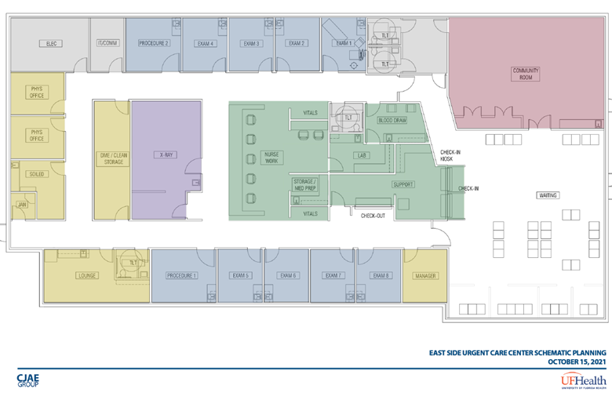  
  
Financial

* UF Health will operate the Urgent Care Center and be fully responsible for the operating P&L, which is projected to be an ongoing negative.
* UF Health owns the property on which the Center is being built and is contributing that in-kind to the project.
* City/County will grant to UF Health an amount up to $4.5M to support the land preparation, building construction and outfitting of the UF Health urgent care center. Once developed, UF Health will own and run the facility. The actual final grant amount will be whatever funds are expended in the preparation, construction, and outfitting of the center, capped at $4.5M.
* The purpose of the City/County grant is ultimately to enable the provision of urgent care services at the location. As such, in the event UF Health ceases to provide urgent care services at the location over a 6-month period,
  + UF Health will pay back the entire amount of the grant if the cessation of services occurs in the first 10 years after opening;
  + UF Health will pay back 75% of the grant amount if the cessation of services occurs between years 10 and 15 after opening
  + UF Health will pay back 50% of the grant amount if the cessation of services occurs between years 15 and 20 after opening;
  + No payback provision exists after 20 years of urgent care service.

Potential future services on site

* UF Health plans for the eastside urgent care campus to expand over time and include additional services beyond urgent care. Although the exact timeline for this expansion is not set, mental health and dentistry providers are already part of the UF Health internal workgroup the project and are very likely candidates for expanded services.
* UF Health expects the Center to augment and work collaboratively with existing nearby public health services and will actively collaborate to make sure that happens.
* UF Health’s vision for the region around the campus is that it could become a hub for additional city and county services and will actively collaborate to make that happen.

Estimated project schedule

* UF Health anticipates the Center opening 15-18 months after receiving the necessary zoning allowances, permits and waivers. We will work with the City and County to accomplish those regulatory approvals as soon as practicable.