FIRST ANNUAL ARTISTS CONFERENCE
REGISTRATION FORM
“Where Nature and Cultural Meet”
Friday, January 21, 2022
8:30 am – 5:00 pm
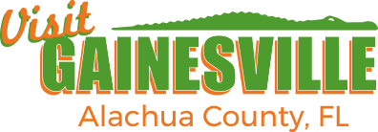
Alachua County Administration Building
Jack Durrance Auditorium

I will attend in-person ____ OR virtually ____ (please check one)

Name:

Agency/Title:

Address:

City/State/Zip:

Daytime Telephone: ( )

Email:

