Alachua County

**Recovery Plan**

**American Rescue Plan**

**State and Local Fiscal Recovery Funds**

Emergency Medical Services Training Facility, Equipment, and Supplies Program

**Executive Summary**

In response to the COVID-19 Pandemic, the Federal government has provided Alachua County funding through the American Rescue Plan – State and Local Fiscal Recovery Funds. This plan includes equipment and supplies to address Category of response for Personal Protective Equipment (1.5), Communications (1.8), Other Public Health (1.12) – Emergency Medical Services Equipment, and Other Public Health (1.12) – EMS Training Facility. Alachua County is currently considered a “hotspot” of transmission. As of the week of August 13th, the County has reported 30,824 cumulative cases, and is at a 14.8% positive test rate. (See Weekly Data Table below). The spread of the Delta variant has resulted in increased demand on hospital emergency rooms and admission, including pediatric admissions. (See Hospital Information table on the next page).

Alachua County is the provider of ambulance transport services in Alachua County. Transports have increased by 21% from October 2020 to July 2021 (See Rescue Unit Responses by Month Table below). The rapid expansion of demand is creating a dramatic increase in the use of personal protective equipment and supplies including N95 masks, gloves, decontamination supplies and disinfecting supplies which goes above and beyond our normal use prior to COVID. In addition, Fire Rescue is in need of additional radio communications equipment, additional Automatic Chest Compression Devices, an additional rescue unit with equipment to address the workload per unit, and a dedicated facility for EMS training.

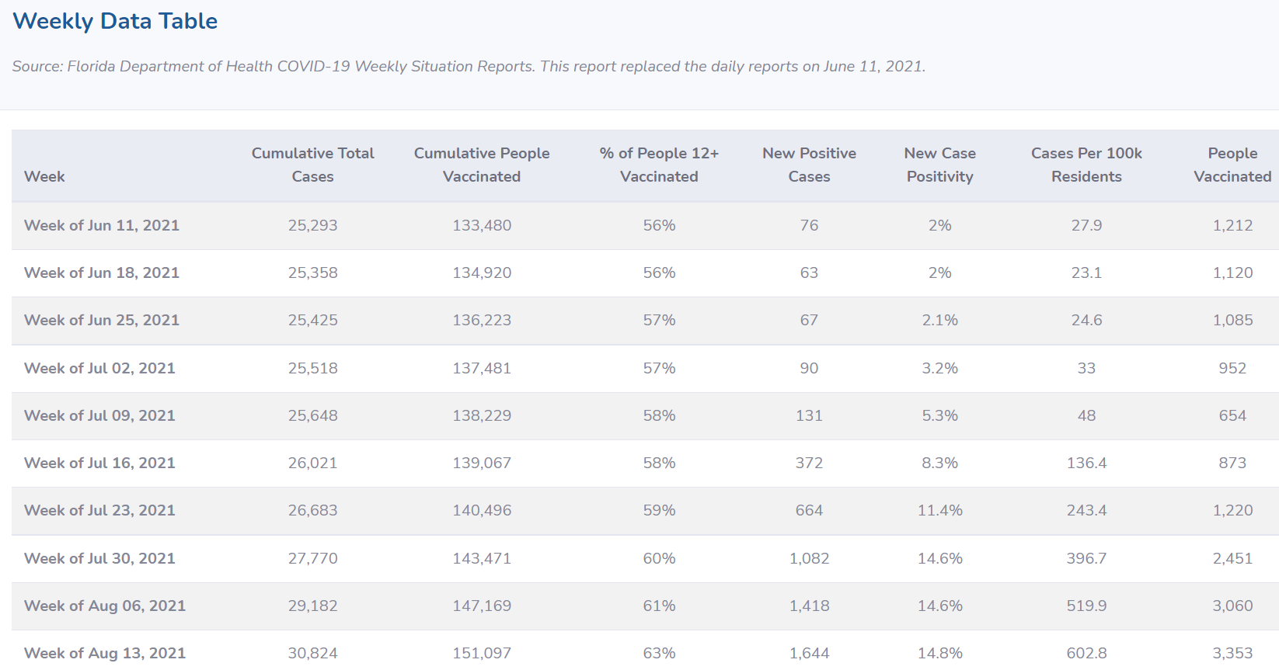

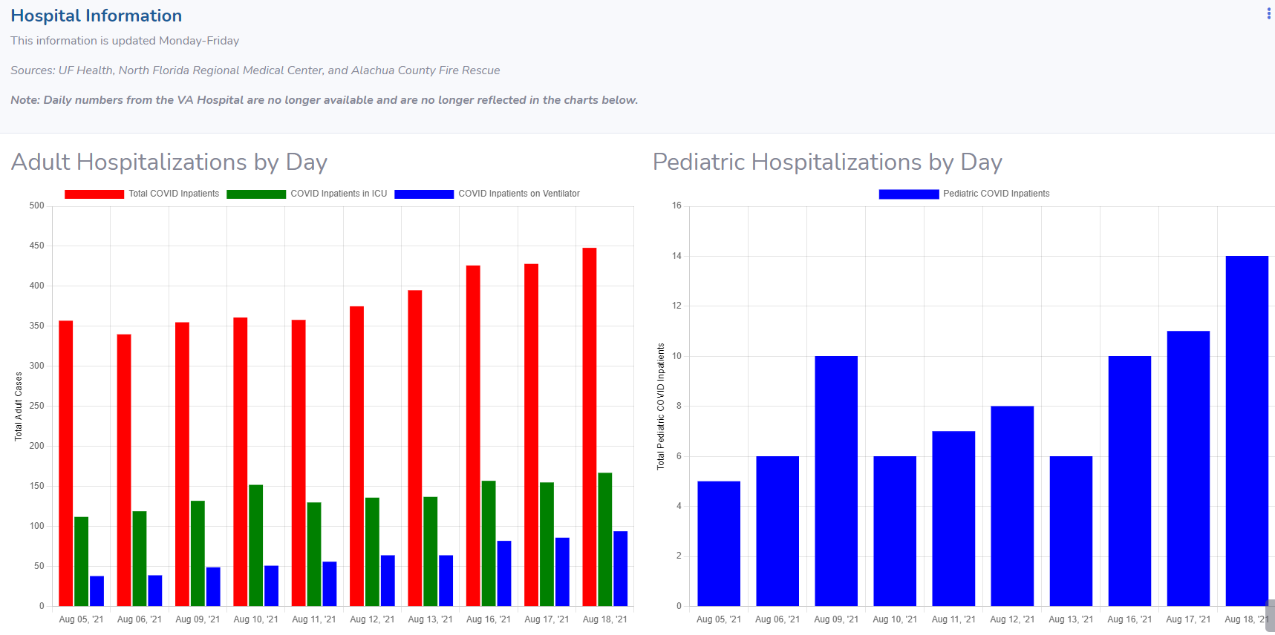

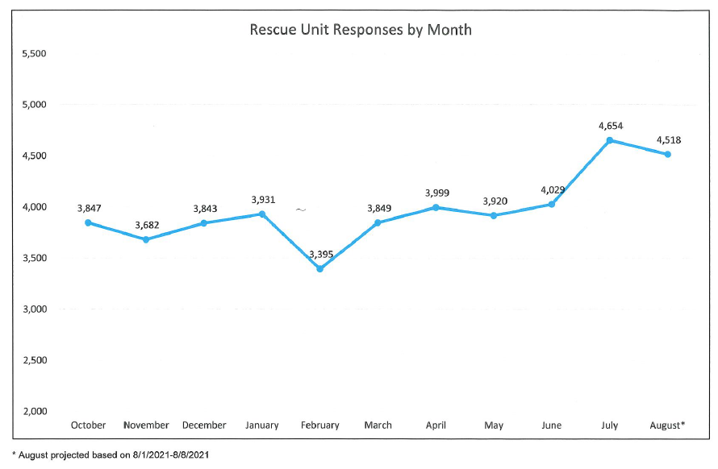



**Uses of Funds**

The Fire Rescue Emergency Medical Services Training Facility, Equipment, and Supplies Program aligns with the Personal Protective Equipment (1.5), Communications – Radio Equipment (1.8), Other Public Health – Rescue Units and equipment (1.12), Other Public Health – Automatic Chest Compression Devices (1.12) and Other Public Health – EMS Training Facility under the American Rescue Plan – State and Local Fiscal Recovery Funds. Having personal protective equipment and supplies, communication equipment, available ambulance transport when the service is needed, appropriate medical equipment and effective EMS Training is critical to the health, and possibly mortality, of the citizenry.

The following purchases will be made under this Program:

Item 1. 1.5 Personal protective equipment and supplies for fire rescue first responders. The items will include masks, gloves, decontamination supplies, disinfecting supplies, etc. which go above and beyond our normal use prior to COVID. The estimated cost will be $205,000.00.

Item 2. 1.8 Alachua County Fire Rescue currently has thirty four (34) vehicle mounted mobile radios that due to age are no longer eligible to be maintained by our vendor. There are no parts available and software upgrades are also not available. It is critical that the radios are replaced in order to ensure a continuation of communication ability of the fire rescue units. The estimated cost will be $170,000.00.

Item 3. 1.12 Over the last several years, the Alachua County Department of Fire Rescue has worked diligently to address the work load issues of our Emergency Medical Services. The territory serviced by Rescue 80 continues to produce the highest demand for service in the County. In FY2020, R80 responded to 4,193 call for service in an area that includes stretches of SR93, two free-standing Emergency Rooms, Butler Plaza, Celebration Pointe, the Archer Road corridor, and numerous assisted living facilities and medical offices. The estimated FY2021 responses for Rescue 80 are 4,642, in addition, Rescue 23 is estimated to exceed 4,100 responses. This new rescue unit will be added as a second rescue to be housed at Station 80 in an effort to bring the call volume per unit to a manageable level. Work load has been reported to be a primary contributor to work stress, fatigue, and low morale amongst the crews stationed at this location. The estimated cost for the additional rescue unit and equipment will be $375,000.00.

Item 4. 1.12 Alachua County Fire Rescue (ACFR) currently has nineteen (19) front line advanced life support (ALS) transport units covering 965 square miles. Performing chest compressions for an extended period of time causes fatigue and can have a negative impact on the quality of CPR. Additional complications with manual COR include interruptions in compressions while moving the patient, physical limitation of the medical providers, and also tying up at least two additional rescuers which are limited in the rural areas of our community. Medical providers who are transporting from rural location on busy highways are also put at an unnecessary risk when not able to be seat belted while doing chest compressions. Automatic chest compression devices (ACCD) have recently become the standard for emergency medical service (EMS) agencies. Currently, only three of ACFR’s transport units are stocked with an ACCD. With transport distances as much as 30 minutes to the hospital, extended times of doing chest compressions leads to fatigue, is not safe for the medical providers and is not as efficient as using an ACCD. The use of ACCDs provides continuous high quality chest compressions that is uninterrupted while moving the patient, during ventilations and while defibrillating. Consistent chest compressions profoundly increases the chance of return of spontaneous circulation (ROSC) and is a lifesaving intervention and the cornerstone of resuscitation from cardiac arrest according to American Heart Association (AHA). The estimated cost to purchase eighteen (18) devices is $400,000.00.

Item 5 1.12 In January of 2022, Alachua County Fire Rescue will acquire a vacant building from the Tax Collector’s Office. This building has been utilized as an in person, customer service center for citizens doing business with the Tax Collector. The building and property are located at 5801NW 34 Boulevard. The department plans to make changes to the interior layout of the building so that it can address several needs related to Emergency Medical Service (EMS) training and new employee onboarding. Approximately half of the building is an open floor plan which will be utilized as an educational classroom, hands-on training, EMS testing assessments, EMS employee skills evaluations, and new employee orientation and training. The building contains several offices in the back that will be occupied by training staff and the Information Technology (IT) section of the department. Additional enhancement will be made to facilitate the additional personnel who are training there as well as base quarters for a future District Chief who will manage EMS and Fire Units stationed in the area.

The estimated cost for these renovations is $450,000.00 of which $350,000.00 will be used from the American Rescue Funding and $100,000.00 from the annual PEMT funds.

The total program maximum cost will be **$1,500,000.**

**Goals and Measures**

The program will begin on October 1, 2021.

Item 1 Personal Protective Equipment - This purchase will occur over the life of the American Rescue Funding period. The goal ensures our first responders are properly protected from contracting and transmitting the COVID virus.

Item 2 Communications Radio Equipment - This purchase will ensure continuity of radio communications for our fire rescue first responder units.

Item 3 Rescue Unit/Ambulance and equipment - The funding of an additional rescue unit will reduce the workload responses for our busiest unit(s) and bring call volumes per unit down to a manageable level.

Item 4 Automatic Chest Compression Devices (ACCD) - Alachua County responded to 283 cardiac arrests from January 1 to December 31, 2020. There were no ACCDs in services during this time period. The County conducted a 6 month trial with LUCAS ACCDs on three transport units. The ROSC rate without the device was 24% and with the device the ROSC rate improved to 57%. When all transports are provided with ACCDs, 93 of the 283 cardiac arrests patients could have been delivered to the emergency room with a pulse. There will be a dramatic increase in survivability of patients in cardiac arrest with a potential of at least 21 more lives saved and returned to their families.

Item 5 EMS Training Facility – This enhancement will create EMS training space that is more closely oriented to the center of Alachua County. It will reduce travel time for on-duty crews which will provide more training opportunities. Additionally, the building provides a better facility for new employee training, large group gatherings and increased space for a growing department.